

**Initial training on soft skills for primary legal aid providers in Latvia**

“Strengthening access to justice in Latvia through fostering mediation and legal aid services”

**Bojana NETKOVA**

LLM, attorney at law, expert in legal aid and access to justice, North Macedonia

**Mar HERMOSILLIA**

Attorney at law, expert on legal aid and mediation, Spain

**John EAMES**

Tribunal judge, expert in legal aid systems, United Kingdom

January 2024

This report is developed in the framework of a cooperation project funded by the Directorate General REFORM of the European Commission and the Council of Europe and implemented by the Council of Europe. The views expressed herein can in no way be taken to reflect the official opinion of the European Union or the Council of Europe

November 2023

Authors:

Bojana Netkova

John Eames

Mar Hermosillia

Contents

INTRODUCTION 2

Purpose and objectives 2

Learning objectives 3

Content and structure of the course: 3

MODULE 1: Soft Skills 4

1.1. Introduction to soft skills 6

1.2. The Importance of Soft Skills 6

1.3. Types of soft skills 7

MODULE 2: Communication skills 7

2.1. What are communication skills 9

2.2. Importance of Communication Skills 10

2.3. Types of communication 12

MODULE 3: Analytical thinking skills/Problem solving skills 21

2.1. What’s analytical thinking? 22

2.2. Types of analytical thinking skills? 23

MODULE 4: Time management and Technological and Digital skills 29

4.1. What is time management? 30

4.2. Consequences of poor time management 31

4.3. Benefits of good time management 32

4.4. Types of time management skills 32

Annex n.1 35

Annex n.2 36

Annex n.3 38

Annex n.4 39

Annex n.5 41

Annex n.7 42

# INTRODUCTION

The Soft Skills training course for primary legal aid providers in Latvia is a specialized program designed to improve the essential interpersonal skills that providers must have to communicate clearly with clients, empathize with their problems, and know how to manage time and stress. It is as important to offer quality technical knowledge to the user as it is to know how to listen to them (Active Listening System), creating a relationship of trust.

Empathy and communication skills are the starting point for good legal advice and a quality advisory service. This involves analytical skills, logical reasoning, and the ability to write and communicate through written and verbal messages.

Learning to organize work time is fundamental, so that the primary legal aid provider knows how to manage several matters at the same time with their respective deadlines, dedicating to each one the necessary time to solve it efficiently and resolutely. The provider must study each specific case to decide whether a referral to other services or secondary legal aid is necessary.

Within the course of the project, the Workshop on the development of a training module for providers of primary legal aid in Latvia was held on 21 October 2022 in Riga with objective to exchange experiences of the stakeholders involved in the legal aid system and to identify the need for trainings of the new legal professionals i.e. the paralegals and what should be the next steps when it comes to training paralegals. Several conclusions arose from the training workshops which were addressed and elaborated in the Assessment report for training on legal aid providers Latvia produced by Ms Bojana Netkova, attorney at law, expert in legal aid and legal aid systems and access to justice, Mr John Eames, expert in legal aid systems, legal aid barrister and judge of the First-tier Tribunal in the UK and Ms Mar Hermosilla, attorney at law, mediation and legal aid expert.

# Purpose and objectives

This training manual provides basic information, instructions and skills for primary legal aid providers i.e. paralegals in Latvia, to provide primary legal aid to indigent people and vulnerable persons in need of legal assistance. The manual provides paralegals with resources needed to provide better access to justice for indigent persons who might otherwise have not had support to resolve their legal problems. It provides skills for paralegals necessary for the effective provision of free legal aid services to the clients.

This document presents a collection of training materials intended to build the capacity of legal aid providers and to equip them with skills necessary for qualitative communication with legal aid beneficiaries. It is also intended to help legal aid providers to design, implement and evaluate their own training programs, and integrate effective learning and teaching methods into them.

The main objectives of these materials are to:

- increase primary legal aid providers' effective communication skills with users, both verbally and in writing, taking into account the different profiles and circumstances of those who use these services.

- develop providers' Active Listening and Assertive Speaking skills to understand and respond to users' needs and concerns, through new communication techniques and soft skills.

- Enhance emotional intelligence to empathize with users and manage interpersonal relationships and emotions appropriately, through empathy, the creation of trusting relationships and the management of complicated situations.

- improve time management and organizational skills to control the workload efficiently, and know how to manage several issues at the same time, by prioritizing tasks and meeting deadlines.

- learn stress management techniques to prevent burnout and promote provider well-being.

# Learning objectives

The participants shall be able to achieve the following objectives at the end of this course:

* Will be able to explain, what are Soft Skills?
* The ways and means by which soft skills can be utilized in the day to day life
* The ability to face the everyday challenges of life with confidence
* The ability to deal with unpleasant situations and people with ease

# Content and structure of the course:

This manual intends to provide paralegals with knowledge and skills to provide legal assistance to vulnerable category of people to navigate everyday issues, assist people with legal needs, assist when they are confronted by rights abuses and seek redress where their rights have been violated.

This manual serves as a guideline that the trainer can use adapting it to his/her own training strategies.

Ideally, when the training is conducted face to face, should be undertaken for a period of 2 consecutive days to enable facilitators to teach the key issues and for participants to understand and participate in role plays, assignments, quizzes i.e. proactive activities and ask the relevant questions to enable them to understand the topics well.

For online training the ideal timeframe should be 2 consecutive weeks, 2 modules per week, accompanied with adjusted quizzes and assignments. At the end of each week online session for practical application of the theoretical part should be conducted by the facilitators/trainers in order to enable the participants to exercise the newly learned soft skills.

The Manual is broken down into 4 modules covering the essential topics related to soft skills for paralegals needed while providing legal assistance to people.

All modules are described in detail bellow. Each topic/chapter consists of objectives, training outcome, exercises and materials for use.

This course is intended for use in a workshop setting and is specifically designed to accommodate offline and online training delivery. Yet, there is a slight difference between sessions designed for offline delivery and those that are planned to be hosted online. For that reason, this document also contains detailed overview of online session which differs from their offline counterparts.

# MODULE 1: Soft Skills

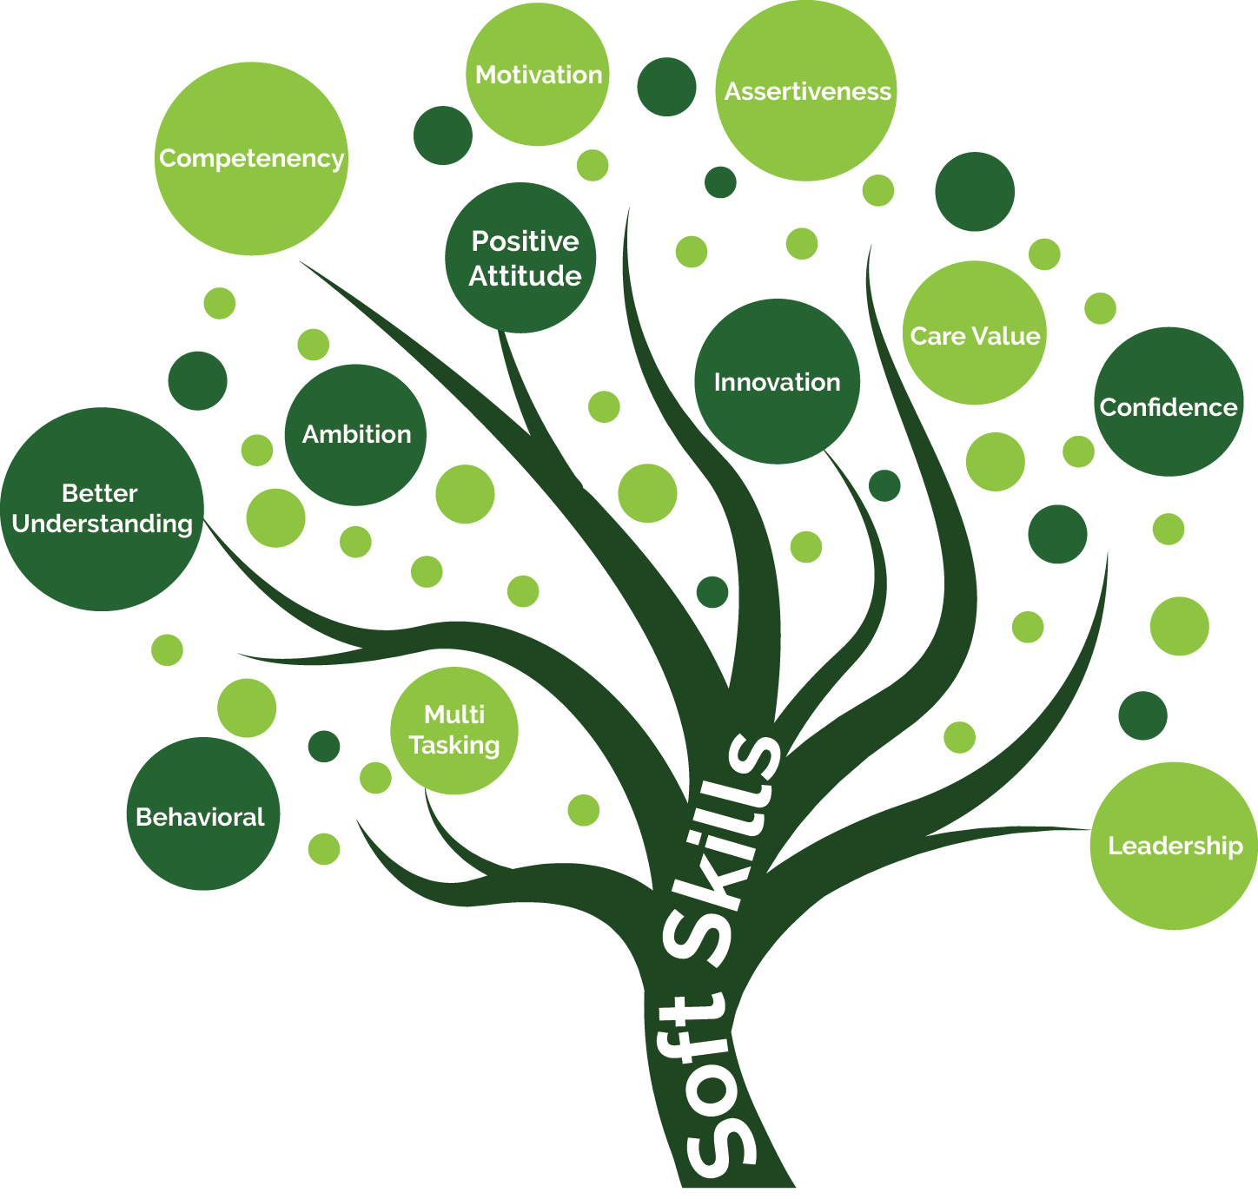

|  |  |
| --- | --- |
| Objectives | The overall objective of Module 1 “Soft skills” is to understand what the soft skills are and which skills are considered as soft skills. This module will introduce the definition of soft skills, the importance of these skills for everyday work of the legal aid providers, the types of soft skills, soft skills vs. hard skills. |
| Learning outcomes | By the end of this module legal aid providers will:   * Have better understanding of what soft skills are and why they are important * Enhance their knowledge on types of the soft skills; * Understand the difference between soft skills and hard skills |
| Participants | Paralegals/primary legal aid providers |
| Duration | 30 - 40 min. |
| Content | Definition of soft skills, types of soft skills, soft skills vs. hard skills |
| Methods | PPt presentation; Role plays, Discussions, Brainstorming |
| Learning materials | Handbook on soft skills, flipchart, markers, Questions for analysis; Case stories for role play and group work |

## 1.1. Introduction to soft skills

Soft skills are interpersonal and behavioral skills that help you to work well with other people. They are personal attributes that directly relate to how well you can work with and interact with others. Soft skills are character traits and interpersonal skills that characterize a person's ability to interact effectively with others. In the workplace, soft skills are considered to be a complement to hard skills, which refer to a person's knowledge and occupational skills.

To have a clearer picture of what soft skills are let’s take a look of several other definitions of soft skills.

* Personal attributes that enable someone to interact effectively and harmoniously with other people.
* Non-technical skills that describe how you work and interact with others.
* Soft skills are something you build through experience.
* Soft skills reflect your communication style, work ethic, and work style.
* Soft skills are the behaviors and characteristics that people demonstrate unconsciously and routinely

Soft skills are the more intangible and non-technical abilities such as:

· Communication · Teamwork · Problem-solving · Leadership · Responsibility

## 1.2. The Importance of Soft Skills

How well you communicate and treat others is crucial to achieving success at work. Trust is developed through positive interactions and relationships, and productivity increases in environments where soft skills are properly developed and used.

The soft skills enable and contribute to build and maintain interpersonal relationships; to make meaningful/appropriate decisions; effective communication; to influence professional development; for effective, efficient and higher performance.

A lack of soft skills can limit your potential, or even be the downfall of your carrier. By developing strong leadership, delegation, teamwork, and communication abilities, you can run projects more smoothly, deliver results that please everyone, and even positively influence your personal life by improving how you interact with others.

Skills such as active listening, collaboration, presenting ideas and communicating with colleagues are all highly valued in the modern workplace. Strong soft skills ensure a productive, collaborative and healthy work environment, all crucial attributes for organizations in an increasingly competitive world. [1]

## 1.3. Types of soft skills

As character traits, it’s fair to say that there are lots of types of soft skills, however the most relevant ones when it comes to primary legal aid providers are:

· Communication skills

· Teamwork

· Critical thinking

· Creativity

· Interpersonal communication

· Adaptability

· Problem solving

· Time management

· Technological and digital skills

· Negotiations

· Decision making

For the purpose of this manual only several of the above mentioned soft skills will be elaborated in detail.

Exercise: Discuss what you think

Trainer: Asks a questions for participants to point out (identify) some of the soft skills a primary legal aid provider should have. (discussion 20 min.)

Examples:

* The ability to listen to the clients (Active listening)
* Honesty and integrity (Confidence)
* Have a polite and considerate attitude (Empathy)
* Judge clients needs and wishes (Judgemental)

For this exercise please see Annex n.1

## MODULE 2: Communication skills

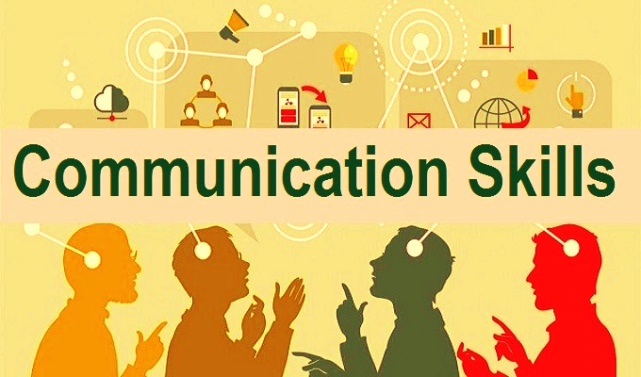

|  |  |
| --- | --- |
| Objectives | The overall objective of Module 2 “Communication skills” is to understand what the communication skills are and which skills are considered as communication skills. This module will introduce the definition of communication skills and the importance of these skills.  The specific objectives are for the participants to understand the importance of communication in providing legal assistance, develop communication skills, obtain interviewing skills and techniques and dos and don’ts in the correspondence. |
| Learning outcomes | By the end of this module legal aid providers will:   * Have better understanding of what communication skills are and why they are important * Enhance their knowledge on types of the communication skills; * Be able to define the manner of application of the communication skills in every day work; * Understand the different types of communication; * Know how to exercise patience during client interviews. * Know issues that can block communication |
| Participants | Paralegals/primary legal aid providers |
| Duration | 180 min. |
| Content | What are communication skills,  Importance of communication skills,  Types of communication skills |
| Methods | PPt presentation; Role plays, Discussions, Brainstorming |
| Learning materials | Handbook on soft skills, flipchart, markers, Questions for analysis; Case stories for role play and group work |

### 2.1. What are communication skills

Communication skills are the abilities you use when giving and receiving different types of information. Communication skills can be defined as the skills used in practical life, whereby a person conveys ideas, concepts, or information to others.[2]

Communication is the act of transferring information from one person to another. The communication process may be conducted in a number of ways – vocally through words, actions, behavior, through written media (books, websites, and magazines), visually (using [graphs](https://corporatefinanceinstitute.com/resources/excel/dashboard-creation-excel/), charts, and maps), or non-verbally (body language, gestures, pitch of voice, and tone) etc., and serves five major goals: informing, expressing feelings, imagining, influencing, and meeting social expectations. Each of these goals is reflected in the form of communication.

Being a good communicator is an essential element for primary legal aid providers. The advisor must know how to convey all information clearly and concisely, adapting to the level of understanding of each user. Listening is an important part of the communication in understanding the needs and concerns of each individual and improving conflict resolution skills.

There are many other indirect ways in which legal aid provider can communicate with others, for example the tone of the voice can give clues to our mood or emotional state, whilst hand signals or gestures can add meaning to a spoken message.

Good communication skills are important when it comes to doing paralegal work, that is, advising clients, counseling, mediating, writing letters, interviewing clients etc.

### 2.2. Importance of Communication Skills

Effective communication is one of the most important aspects of life. Good communication skills are essential to allow others and yourself to understand information more accurately and quickly. Well developed communication skills help achieve the goals planned in advance, provide a clear-cut vision about those goals, and achieve good preparation for them in an appropriate environment.

Effective communication is about more than just exchanging information. It's about understanding the emotion and intentions behind the information. As well as being able to clearly convey a message, you need to also listen in a way that gains the full meaning of what's being said and makes the other person feel heard and understood.[3]

Effective communication skills are of great importance, including:

* A person's success in his life is related to his mastery of effective communication skills
* Effective communication skills facilitate the behavior of individuals and direct them towards desired matters
* Align and converge viewpoints, concepts, and ideas, and standardize working methods
* Give the individual a characteristic of calm, sluggishness, and patience; Which leads him to be wise in launching his decisions and judgments
* Help make correct decisions and make appropriate and sound judgments

What are the barriers to effective communication?

**Stress and out-of-control emotion**

When [you're stressed](https://www.helpguide.org/articles/stress/stress-symptoms-signs-and-causes.htm) or emotionally overwhelmed, you're more likely to misread other people, send confusing or off-putting nonverbal signals, and lapse into unhealthy patterns of behavior. To avoid conflict and misunderstandings, you should quickly calm down before continuing a conversation.

**Lack of focus**

You can't communicate effectively when you're multitasking. If you're [checking your phone](https://www.helpguide.org/articles/addictions/smartphone-addiction.htm), planning what you're going to say next, or daydreaming, you're almost certain to miss nonverbal cues in the conversation. To communicate effectively, you need to avoid distractions and stay focused.



**Inconsistent body language**

Nonverbal communication should reinforce what is being said, not contradict it. If you say one thing, but your body language says something else, your listener will likely feel that you're being dishonest. For example, you can't say “yes” while shaking your head no.



**Negative body language**

If you disagree with or dislike what's being said, you might use negative body language to rebuff the other person's message, such as crossing your arms, avoiding eye contact, or tapping your feet. You don't have to agree with, or even like what's being said, but to communicate effectively and not put the other person on the defensive, it's important to avoid sending negative signals.

**Use of legal language**

An over-complicated, unfamiliar and/or technical term usually represents a barrier. The primary legal aid provider must be able to translate legal language into terminology easily understood by service users. Users are often intimidated by legal vocabulary. Simplifying the overuse of legal terminology by explaining legal concepts in a clear and easy-to-understand style will promote better understanding and reduce confusion.

Exercise: Communication barriers

Trainer: Explains the activity and spreads out printed statements

Materials: Printed statements

Duration: 30 min.

For this exercise please see Annex n.2

### 2.3. Types of communication

The primary types of communication are:

2.3.1. Verbal communication

Verbal communication skills refer to the way you relay a message through words. This can include face-to-face talking, listening to a lecture or seminar and listening to a television program. The primary goal of verbal communication is to use language to convey information clearly and concisely.

Verbal communication skills are most often employed during three situations: interpersonal communication, group conversations and public speaking. Interpersonal communication refers to one person directly communicating with another person.

In verbal communication the attention should be on the types of words being used by the legal aid provider. Some words express exactly what the word means (objective meaning of the word) i.e. the meaning attached to them is literal. These types of words are denotative words and they do not include the feelings and ideas that people may connect with that word.

Connotative words on the other hand express the subjective, intellectual or emotional meaning of the word. *“Connotation is non-literal farming of a term that intends to add an association beyond its literal meaning.”[4]*

Example:

Four-leaf clover 

Denotation

(Express the literal meaning of the word i.e. a trifolium clover with four-leaves)

Four-leaf clover 

Connotation

(Express the subjective or emotional meaning of the word i.e. good luck)

Connotations can have negative, neutral or positive implications on a term.

Example:

* Positive connotation of aged: vintage
* Neutral connotation of aged: old
* Negative connotation of aged: decrepit

Trainer: Ask participants examples of connotative words in their everyday life or from their work surroundings (discussion 10 min.)

2.3.2. Non-verbal communication

Exercise: What do you know?

Trainer: Explains the activity and spreads out printed materials

Materials: Printed leaf sheets with several questions/short quiz for evaluation of the knowledge of everyday communication

Duration: 15 min.

For this exercise please see Annex n.3

Nonverbal communication is expressed through nonlinguistic means.

“The Non-Verbal Communication is the process of conveying meaning without the use of words either written or spoken. In other words, any communication made between two or more persons through the use of facial expressions, hand movements, body language, postures, and gestures is called as non-verbal communication.”[5] It includes behaviors such as facial expressions, eyes, touching, and tone of voice, as well as less obvious messages such as dress, posture and distance between two or more people.

“The Non-Verbal Communication, unlike the verbal communication, helps in establishing and maintaining the interpersonal relationships while the verbals only help in communicating the external events. People use non-verbals to express emotions and interpersonal attitudes, conduct rituals such as greetings and bring forward one’s personality.”[6]

The meanings of the nonverbal messages that accompany the verbal messages are crucial to be understood in appropriate manner in order to understand the importance of the non-verbal communication.

The meaning of our words can be changed within a seconds by a certain facial expression, voice tone, bodily movement, use of space, or touch. By building our ability to use and interpret nonverbal behavior, our understanding of interpersonal relationships will improve.

For example:

Examples:

1. The little boy who hides behind his mother as he says, “I’m not afraid of the dog.”

2. The woman who says, “I love you,” to her spouse while hugging him and smothering him with kisses.

3. The teacher who asks, “Any questions?” and fails to wait for a response before moving on to the next point.

4. The child whose eyes are downcast and shoulders are rounded as she says, “I’m sorry for breaking the vase.”

Each message contains nonverbal cues that help reveal what a person is feeling. As we see, nonverbal cues are integral to communication. As the preceding situations illustrate, they may:

* Contradict words

Nonverbal cues can contradict or negate verbal messages.

Example: The face of the woman is contorted and red, her eyes are narrowed and eyebrows furrowed, yet, she is saying, “I am not angry!”

.

You are sending a mixed/double message (The message that is communicated when words say one thing and nonverbal cues another)

* Emphasize or underscore words

Nonverbal gestures can emphasize or underscore a verbal message.



Example:

Raising or lowering your voice, or slow down your rate of speech so you can deliberately stress a series of words, you are using nonverbal cues to accentuate your words.

* Regulate their flow

Nonverbal cues can regulate or control person to-person interaction. With eye contact, gestures, and voice we control who should speak next and thus direct the flow of verbal exchanges.



* Complement words

Nonverbal cues can reinforce or complement a verbal message. With the backpack on his back and the hat on his head, Peter announces, “I have to leave now,” as he walks toward the cab.

* Substitute for or take the place of spoken words

Nonverbal cues can substitute for or take the place of spoken words.

Examples:

Using a hug (embrace) as a non-verbal gesture to comfort a friend who has lost a loved one.

When someone asks, “What do you want to do tonight?” a shrug of the shoulders is always used to symbolize “I don’t know.”

Whereas words are best at conveying thoughts or ideas, nonverbal cues are best at conveying information about relational matters such as liking, respect, and social control. To be sure, the meaning of neither verbal nor nonverbal messages should be interpreted without carefully considering the other.[7]

***Types of nonverbal communication are:***

* **Eye Contact**: is used to show interest in a conversation. It is also a sign of respect and can show agreement or understanding. Conversely, if someone is avoiding eye contact, it may indicate confusion or disagreement. The amount of eye contact often determines the level of trust and trustworthiness. “Eye contact also indicates whether a communication channel is open. It is much easier to avoid interacting if we have not made eye contact, because once we do, interaction virtually becomes an obligation.”[8]

What to do?

Look the person in

the eye during the conversation.

* **Facial expression**: The face is an important communicator. It is commonly said that the face is the index of the mind. It expresses the type of emotions or feelings such as joy, love, interest, sorrow, anger, annoyance, confusion, enthusiasm, fear, hatred surprise, and uncertainty. They can also be used to show agreement or disagreement with something.

For example: If a person is frowning, they may not agree with what is being said.

* **Appropriate touch**: Appropriate touch can be used to show support or affection, such as a hug or pat on the back. If used in the wrong context, however, it can be seen as intrusive or threatening.

For example: If somebody is avoiding or pulling away, it’s a sign that they do not want to be touched.

* **Gestures**: Gestures are movements of the hands and arms that can convey various meanings.

For example:

A thumbs-up gesture is often used to indicate approval or agreement.

If a person is rubbing their chin, they can think deeply or consider a situation.

Exercise: What do these mean?

Trainer: asks participants to interpret the forms of non-verbal communication below to demonstrate their understanding of non-verbal communication.

Duration: 30 min.

Could have participants do a role play

|  |  |
| --- | --- |
| *ACTION* | *POSSIBLE MEANING* |
| Smiling or laughing when messages are serious | You are not taking the message seriously |
| Interrupting people when they are talking | You do not value what the other person is saying |
| Introducing yourself with a smile and a firm handshake | Shows that you are confident |
| Leaning slightly forward | Indicates interest |
| Folding arms | Can convey defensiveness |
| Nodding | Demonstrates understanding |
| Looking at the clock, your phone | You are not paying attention or not listening/ Shows disinterest |

2.3.3 Active listening

Listening is the ability to accurately receive and interpret messages in the process of communication. When listening, the person is paying attention not only to the story, but the manner of telling the story, the way language is used or the tone of the voice, and how the other person uses his or her body. It means being aware of both verbal and non-verbal messages.

Active listening, however, is one of the most important types of communication because if we cannot listen to the person sitting across from us, we cannot effectively engage with them. “It means going beyond simply hearing the words that another person speaks but also seeking to understand the meaning and intent behind them. It requires being an active participant in the communication process.

Active listening techniques include:

* Being fully present in the conversation
* Showing interest by practicing good eye contact
* Noticing (and using) non-verbal cues
* Asking open-ended questions to encourage further responses
* Paraphrasing and reflecting back what has been said
* Listening to understand rather than to respond
* Withholding judgment”[9]

Concentration

During the listening process, the primary legal aid provider should focus his/her attention on the user, avoiding distractions caused by noise, lights or temperature. The place where the interview between client and advisor takes place should have a comfortable and safe environment.

Withholding judgment

The primary legal aid provider should avoid being prejudiced during the interview against the user because of his/her physical characteristics such as features, clothing, accent, etc. In Active Listening, the advisor should be open to understanding the user and the message he/she wants to convey, without judgment.

Use empathetic language

Both verbal and non-verbal language used by the provider should convey confidence, empathy and attention to what the user is saying.

Listening to understand rather than to respond

The provider should not interrupt the user's message. The provider should wait patiently for the user to finish and should avoid giving a premature answer before the user has finished his or her question.

Paraphrasing and reflecting back what has been said

The provider should be able to listen not only to what is important but also to what may seem unimportant. Sometimes unimportant details can become the key element in resolving a conflict.

What to do if you're finding it particularly difficult to concentrate on what someone is saying.

Try repeating their words mentally as they say them. This will reinforce their message and help you to stay focused.

To enhance your listening skills, you need to let the other person know that you are listening to what they're saying.

Try to respond to the person in a way that will encourage them to continue speaking, so that you can get the information that you need. Nodding will send a message that you're interested and occasional question or comment to recap what has been said will communicate that you are listening and understanding the message.

Common Barriers to Listening

* Emotional barriers and taboos. Some people may find it difficult to express their emotions and some topics may be completely 'off-limits' or taboo.
* Lack of attention, interest, distractions, or irrelevance to the receiver.
* Physical barriers to non-verbal communication. Not being able to see the non-verbal cues, gestures, posture and general body language can make communication less effective.
* Language differences and the difficulty in understanding unfamiliar accents. Even when communicating in the same language, the terminology used in a message may act as a barrier if it is not fully understood by the receiver(s). For example, a message that includes a lot of specialist jargon and abbreviations will not be understood by a receiver who is not familiar with the terminology used.
* Expectations and prejudices which may lead to false assumptions or stereotyping. People often hear what they expect to hear rather than what is actually said and jump to incorrect conclusions.
* Psychological Barriers: the psychological state of the communicators will influence how a message is sent, received and perceived. For example: If someone is stressed they may be preoccupied by personal concerns and not as receptive to the message as if they were not stressed. Anger is another example of a psychological barrier to communication, when we are angry it is easy to say things that we may later regret and also to misinterpret what others are saying.
* Attention is divided between several cases at the same time, making it difficult to concentrate on solving specific problems.
* Being overloaded with information, making it difficult to draw clear and simple conclusions.
* Inappropriately attending to the service user.

Benefits of Active Listening

* It generates an atmosphere of trust between interlocutors, increasing the effectiveness of communication.
* It facilitates the receipt of complete and relevant information for the primary legal aid provider.
* It increases credibility and cooperation between interlocutors, facilitating the flow of information.
* It helps to capture the exact meaning of the message, providing secure and reliable information.
* It makes it easier to grasp the user's needs and the existence of problematic situations.

Exercise: Barriers to active listening

Trainer: Starts a discussion/brainstorming on what other barriers exist to active listening

Duration: 15 min.

Possible outcomes: Please see Annex n.4

# MODULE 3: Analytical thinking skills/Problem solving skills



|  |  |
| --- | --- |
| Objectives | The overall objective of Module 3 “Analytical thinking skills” is to understand what analytical thinking is and which skills falls under the analytical thinking skills. This module will introduce the definition of analytical thinking, which skills are considered as analytical thinking skills and elaborate the importance of these skills. |
| Learning outcomes | By the end of this module legal aid providers will:   * Have better understanding of what analytical thinking are and why they are important * Enhance their knowledge on types of the analytical thinking skills; * Be able to define the manner of application of the these skills in every day work; |
| Participants | Paralegals/primary legal aid providers |
| Duration | 120 min. |
| Content | What is analytical thinking  Types of analytical thinking skills |
| Methods | PPt presentation; Role plays, Discussions, Brainstorming |
| Learning materials | Handbook on soft skills, flipchart, markers, Questions for analysis; Case stories for role play and group work |

## 2.1. What’s analytical thinking?

Analytical skills aren’t just about facts and figures. They also require creativity to brainstorm solutions and possible answers to problems.

Analytical thinking involves the research and analysis of complex issues for developing new ideas or finding solutions. Analytical skills are critical for work and listed as required in many job descriptions.[10] Analytical skills refer to an individual’s ability to identify a problem, investigate to find out relevant facts, and find a logical solution. They are considered important skills in many different fields.[11]These skills are special type of soft skill that can develop through experience and reflection.

The primary legal aid providers need analytical thinking skills for working data, brainstorming ideas, solutions, and making decisions based on factors and options i.e. sound information. They must be able to analyze data, identify problems and find effective solutions. Analytical skills are the ability to collect information and to thoroughly analyze that information. They refer to problem-solving skills and making a decision based on insights drawn from the collected information.

Analytical skills are used when detecting patterns, brainstorming ideas, observing data, collecting data, interpreting data, integrating new information, synthesizing information, and making decisions based on the situation.

Analytical skills are crucial because they allow people to find solutions to various problems and make concrete decisions and action plans to solve those problems.

How does analytical thinking work?

“An essential element of analytical thinking is the ability to identify cause and effect in every relationship. This entails understanding what might happen during the problem-solving process, and examining how new ideas relate to the original topic. The process of applying the analytical skills involves several steps, including:

* Identifying a topic, problem or issue
* Gathering information through testing and observation
* Developing solutions or deepening your understanding of the topic
* Testing solutions or new ideas based on what you’ve learned
* Reviewing what solutions worked to assess and apply your new knowledge”[12]

Even though some technical skills are involved in analytical thinking, much of analytical thinking relies on your soft skills which means it’s harder to know how to be a better analytical thinker. However, by understanding your current problem-solving process and asking others about theirs, you’ll start to hone your analytical skills.

## 2.2. Types of analytical thinking skills?

Many valuable analytical skills are worth knowing and also mastering. However subject of elaborating in this manual are only several of them, essential for primary legal aid providers.

2.2.1. Creative and critical thinking

Creativity helps analytical people move away from the small points and think big picture.  The ability to think creatively is a very important skill. Many problems require out-of-the-box thinking in order to find the optimal solution. The obvious solution may not always be the most effective, and therefore, it is important to be able to think of creative solutions. Creative thinking relates to problem-solving and is a key skill for many jobs. To analyze information you need to be creative to notice hidden spots or trends not everyone can see. Creative thinkers can find a non-trivial solution that is more valuable than the obvious one. Creative people think outside the box to work out an effective solution or brainstorm ideas.

Examples of analytical creativity skills include:

* Innovation
* Empathy
* Feedback
* Risk-taking
* Storytelling

**The elements of creative thinking are:**

* Optimizing processes and operations
* Collaboration for brainstorming with others
* Solving complex problems in a non-trivial way
* Thinking strategically
* Integrating massive volumes of information into existing solutions

Critical thinking is the ability to question preconceived notions, which can help you identify issues or areas for improvement. Critical thinking skills allow you to understand and address situations based on all available facts and information. Typically, using critical thinking at work involves processing and organizing facts, data and other information to define a problem and develop effective solutions.

Critical thinking is the act of analyzing facts to understand a problem or topic thoroughly. The critical thinking process typically includes steps such as collecting information and data, asking thoughtful questions and analyzing possible solutions.

For example: As a legal aid provider you need to think of possible solutions for resolving a conflict/issue, problem between the client and the third party, so you will use critical thinking to understand the nature of the conflict and what action should be taken to resolve the situation.

2.2.1. a. Empathy

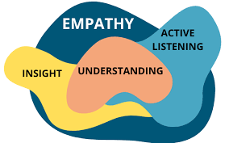

When you empathize with someone, you can aim to understand their viewpoint and give opportunities for them to express it. There are several components of empathy that often affect the way you communicate with fellow professionals. Empathic skills are abilities that relate to the identification and use of emotions in the workplace. You can remain informed of your own thoughts and feelings, and you can identify how your colleagues may feel as well. Empathy is often present during conversations in the professional environment. They enable you to view a situation from your perspective and compare it to the perspective of a coworker. You can also show that you're open to adopting new points of view.[13]

Some examples of empathic skills that can be used by primary legal aid providers:



**Curiosity**

**With curiosity, you can channel the viewpoints of people you encounter at work, such as teammates, supervisors and stakeholders. Curiosity can evoke inquisitiveness, which encourages you to ask questions and learn as much as you can about a certain topic**.

**Self-awareness**

**Having self-awareness enables you to discover how your emotions affect your professional conduct, which can also influence your interactions in the workplace. You can evaluate your own thoughts and take responsibility for your actions. You can also identify opportunities to increase your productivity.**

**Having self-awareness often includes extensive knowledge of yourself, including personal values and behavioral patterns.**

**Emotional intelligence**

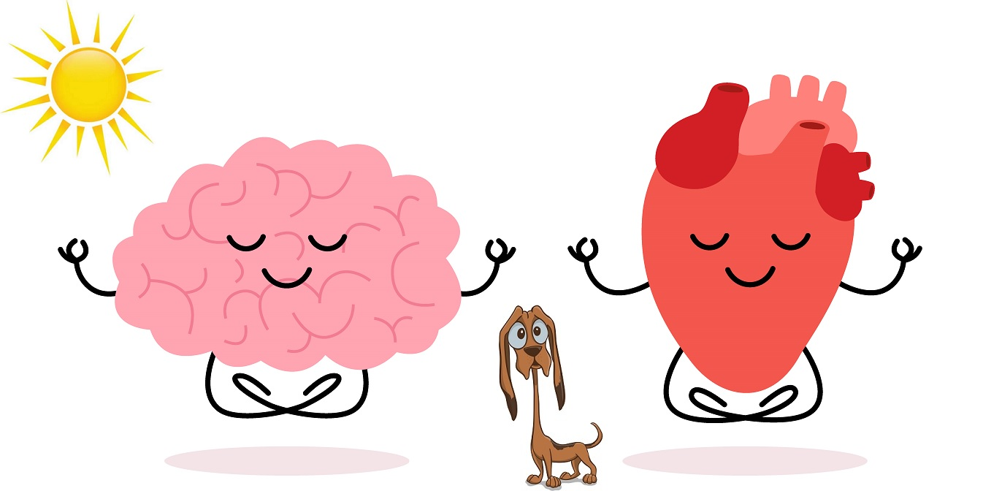

**As a legal aid provider, it is important for you to be aware of the feelings of your clients/beneficiaries. Emotional intelligence can empower you to assess signs of your clients' emotional states, which can include body language and communication patterns. Your analysis can allow you to provide emotional and mental support when necessary.**

**Exercise: Paper clip**

Trainer: explains the activity to the participants and hands them a box of paper clips

Duration: 45 min.

For detailed explanation of the exercise please see Annex n. 5

2.2.2. Research

Conducting an in-depth research is an integral part of analytical thinking. To solve a problem, you need to learn more about it. In simple words, you need to gather information before analyzing it.

This part of the analytical thinking process can involve various types of research and depends on the source of data. You can do online research, gathering information by comparing competitives, reviewing official documents, or interviewing experts, etc. It’s also valuable to know what kind of data is required for problem-solving.

**To conduct a research, you need to be able to:**

* Investigate the topic based on different data sources.
* Work with metrics.
* Prioritize data sources.
* Pay attention to the accuracy of the collected data.

2.2.3. Problem solving skills

A problem-solving skill helps the provider to determine the source of a problem, brainstorm and analyze answers and find an effective solution. Although problem-solving is often identified as its own separate skill, there are other related skills such as all of the above mentioned skills that contribute to this ability.

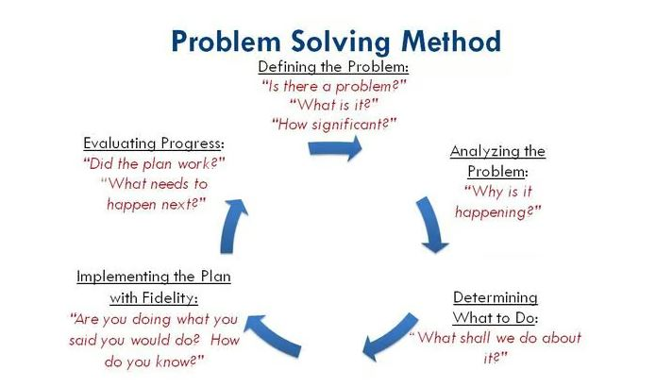

**Exercise: A Shrinking Vessel (Adaptability)**

Trainer: explains the activity to the participants

Materials: Rope

Duration: 40 min.

For detailed explanation of the exercise please see Annex n. 6

**Exercise: Egg Drop (Collaboration, decision-making)**

Trainer: explains the activity to the participants

* Materials: A carton of eggs, Basic construction materials such as newspapers, straws, tape, plastic wrap, balloons, rubber bands, popsicle sticks, etc., tarp, or drop cloth, a room or some other place you don’t mind getting messy!

Duration: 40 min.

For detailed explanation of the exercise please see Annex n. 6

# MODULE 4: Time management and Technological and Digital skills



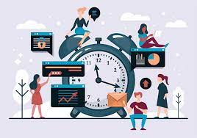

|  |  |
| --- | --- |
| Objectives | The overall objective of Module 4 “Time management and Technological and digital skills” is to understand what these skills are. This module will introduce the definitions of these skills and the importance of these skills for everyday work of the legal aid providers. |
| Learning outcomes | By the end of this module legal aid providers will:   * Have better understanding of what Time management and Technological and digital skills are and why they are important |
| Participants | Paralegals/primary legal aid providers |
| Duration | 120 - 150 min. |
| Content | What is time management, Task planning and scheduling, Consequences of poor time management, Benefits of good time management, Mastering digital tools, Digital communication, Collaborative networking |
| Methods | PPt presentation; Role plays, Discussions, Brainstorming |
| Learning materials | Handbook on soft skills |

## 4.1. What is time management?

Time management is a soft skill that ensures you get your work done efficiently and effectively and on deadline.

Good time management skills aren't always intuitive, but they're critical for workplace success. Managing your time effectively is an important professional skill to develop. Organizing your tasks each day helps you complete work on time, prioritize your projects and communicate your progress to supervisors and colleagues. Correct time planning will help to complete tasks more quickly, making more efficient use of the time spent. By planning the work properly, the provider will know what has to be done at each moment, without intermediate pauses or hesitation in decision making.

## 4.2. Consequences of poor time management

* **Disorganization**

When working without structure, the person will likely jump from one task to another without finishing it. The provider who does not organize his time properly will probably not put the necessary concentration in one case when he/she is busy with another. This is the gateway to chaos.

* **Postponement of tasks**

Postponing urgent tasks without objective or rational reasons, and which have a pre-established deadline, is a bad habit that may cause the provider to delay the completion of a task until the last moment, and may thus harm the user's interests.

* **Over-tasking**

The provider who manages his/her time badly often takes on a high and excessive number of tasks and activities that he/she cannot carry out, so he/she often ends up overwhelmed, unable to fulfill everything he has promised.

* **Increased Stress**

It can lead to elevated stress levels when you consistently struggle to meet deadlines or accomplish tasks on time. Chronic stress can have detrimental effects on your physical and mental health, causing anxiety, burnout, and a reduced quality of life.

* **Lower Productivity**

Poor time management often means that you spend more time on less important tasks and less time on critical ones. This can result in reduced overall productivity, as you may find yourself working longer hours to compensate for inefficiency.

* **Decreased Quality of Work**

Rushing through tasks or trying to complete multiple tasks simultaneously due to poor time management can lead to a lower quality of work. Errors and oversights become more likely when you’re under time pressure.

## 4.3. Benefits of good time management

* Good time management makes it possible to be more effective in the administration and accomplishment of tasks, reducing stress levels due to dispersion and disorder.
* Focus and concentration on the task. This will allow for more optimal results when it comes to advising the user properly.
* Prioritization of tasks by order of urgency and importance. Proper time management will help to accomplish a greater number of tasks in a specific time frame, thanks to the appropriate focus and distribution of work, and respecting the established deadlines.

4.4. Types of time management skills[14]

Some of the most important time management skills include:

4.4.1 Organization

Staying organized can help you maintain a clear picture of what you need to complete and when. Being well-organized might mean maintaining an up-to-date calendar, being able to locate certain documents easily, having a tidy environment and taking detailed, diligent notes.

4.4.2. Prioritization

To effectively manage your time, you will need to decide in which order you should complete your tasks. Reviewing your schedule each day and labeling your to-do list with whether tasks are urgent, important, or neither can help you decide when and how to manage your time throughout the day. In general, you will want to prioritize your urgent tasks in the order of their importance. Following this, you can complete your non-urgent tasks in the same manner. This makes sure you complete critical tasks with the needed attention and time.

One key difference when prioritizing tasks will be between “urgent” and “important” tasks. Urgent tasks are ones that you *must*complete as soon as possible, while important tasks are those that matter, and not doing them may lead to negative consequences, but there is more flexibility on when they get done.

***Example:***

**If you are expecting an important phone call and your phone rings, then picking up the phone call is an urgent task. This is because it is a task that demands your immediate attention.**

4.4.3. Goal setting

Goals give a measurable way to determine progress toward the end product. Setting goals can help you organize your to-do list and determine the priority of your tasks. If you have a goal set for the end of each week or month, then you can create a priority list specifically for each goal. This can reduce the feeling of being stressed or overwhelmed when working toward larger goals.

4.4.4. Planning

Writing down your schedule can give you a realistic idea of how much time you have to allocate to different tasks.

For example: You may have a standard 9-to-5 work day and assume you have eight hours to complete your five project-based tasks of the day. Let’s say you then write down your schedule, and see you have an hour-long lunch meeting, a 30-minute internal meeting on a different floor, and have to leave 30 minutes early to pick up your kids from school. When you write this down, you see you actually have six hours outside of meetings.

By breaking down your schedule, you’ll realize each meeting is a 10-minute walk from your office. In addition to this, you know it takes you at least 10 minutes to get organized at your desk before beginning work each time you return, and you will need a 30-minute break in the day to recharge. You now realize you have to factor in 40 minutes of walking time and 50 minutes of non-working time at your desk. This leaves you 4.5 hours of working time for your project-based tasks.

By writing down your schedule, you can better allocate time for each task and make reasonable plans for your day.

4.4.5. Delegation and Setting boundaries

Delegating tasks is an important skill to avoid being overwhelmed. If you have the capacity to delegate tasks within your workplace, consider assigning certain projects to team members that have the capacity to take them on. This gives you time to focus on more challenging tasks.

If your supervisor or colleague asks you to complete a task and you do not have the time, practice being assertively honest about your work capacity and current workload. Taking on too many responsibilities can prevent completing important work and contributes to missing deadlines.

4.4.6. Automation

Many technologies exist to automate common workplace tasks. Legal aid primary providers must be familiar with legal-specific digital tools, such as case management software, online research tools, collaboration platforms and mobile applications to access legal information anytime, anywhere. They should know how to properly navigate the internet and where to look for sources of information, identifying their validity, currency and reliability.

a Digital communication

It is the ability to communicate, relate and collaborate efficiently with digital tools and environments. Digital communication skills mean being able to create professional relationships in the virtual context, knowing how and when to send messages, information or attachments, using the right channel and format. An important element is the ability to use the videoconferencing tool correctly.

b. Collaborative networking

It is the ability to work, collaborate and cooperate in digital environments, using tools to develop asynchronous or remote teamwork (e.g. cloud-based documents, real-time collaborative file editing, task calendars and project management platforms).

**Exercise: The game of 60 seconds**

Trainer: explains the activity to the participants

Duration: 15 min.

Materials: None

For instructions for this activity see Annex n. 7

**Exercise: Puzzle**

Trainer: explains the activity to the participants

Duration: 40 min.

Materials: Boxes of puzzles

For instructions for this activity see Annex n. 7

# Annex n.1

[15]**Exercise: Think about it**

Questions for discussion:

1. Would you like to work with someone who never smiles, always negative and is always in a bad mood?

2. Do you know someone who never takes part in things, never helps or listens to others, always does the minimum and yet takes all the credit?

Are you that person?

3. Have you ever witness a situation where client was served by person with poor soft skills or have you ever experience yourself this kind of situation?

# Annex n.2

**EXERCISE: Communication Barriers**

**Time allocation: Around 30 minutes depending on the size of your group**

**Resources: Printed sample statements**

This exercise is best done with a group, but it can be amended to be done with just one person and the communication mentor, who should play the part of Partner A or B.

1) Ask people to split into pairs with one becoming Partner A and one becoming Partner B. Give each person a piece of paper with a message on it. (See below for the messages to give them – you should write these out beforehand). They shouldn’t look at this message at this time. Instead, tell them to have a discussion about anything at all that comes to mind. As the discussion unfolds, tell them you will shout out instructions for A and B at various points.

2) After a few minutes discussion, ask Partner A to stand up. Tell them to keep their discussions going.

3) After a few more minutes tell Partner B to turn their head away from A.

4) Then tell A to sit back down but close their eyes.

5) Tell A to also turn their head away from B.

6) Tell them to turn back-to-back with each other and keep their conversation going.

7) Then shout out to STOP the conversation.

8) Ask Partner A to look at their message. Without using any speech or recognised sign language, they should pass their message to B. (If you have not written out any messages, then just ask partners to tell each other what they did last night, or what they had for dinner etc).

9) Ask Partner B to look at their message. Without using any speech or recognised sign language, and while sitting on their hands, they should pass their message to A.

10) Then have some general feedback on the exercise, concentrating first on the messages. Who managed to pass their message on? How did you do this? How did the other guess what was meant? Were any messages easier than others? Why is this? What’s make it sometimes easy and sometimes difficult?

11) Then discuss the earlier part of the exercise. What was easy? When did communication become difficult? Why was this? What barriers get in the way? What would make this easier?

Messages to pass to your partner (These can be amended to fit particular venues and situations – i.e. make some of the statements specific to the location where training is taking place).

It’s cold in here

It’s really hot in here

What did you have for dinner last night?

My favourite meal is Chilli con Carne.

I like Coronation Street

Do you have any children?

I am completely bored in here.

I hope it’s lunch soon.

I hope we get spaghetti for lunch.

That’s really nice wallpaper in here.

What a horrible colour of carpet.

You’ve got nice shoes.

I like watching TV.

I enjoy going to the cinema.

General themes that might emerge from this exercise:

1) It is important to have a response – without eye contact or another way of knowing that your partner is listening to you, it can make you feel very frustrated – how might this relate to the people you support?

2) Background noise makes communication very difficult.

3) Different levels (e.g. standing and sitting) creates problems and barriers.

4) Concrete objects that in the here and now are easier to talk about than something removed from the situation. (For example, you can point to a TV in the room if one is there, but you’ll be less likely to point to Chilli con Carne).

5) Feelings are easy to talk about if we can re-create a facial expression or body movement to indicate what’s in our mind. More subtle emotions are difficult to portray without words.

6) The importance of seeing communication as a partnership.

For each point that is made by participants, a challenge person to consider what this means for the people they support and the communication partnerships that exist between them. What, for example, does it tell us about signifiers and objects of reference? If somebody they are supporting wishes to talk about an activity they have done together, would they have a way of doing this?

# Annex n.3

# Annex n.4

**EXERCISE: Barriers to active listening**

**Duration:**

**Resources:**

Possible responses to the brainstorming:

* Trying to listen to more than one conversation at a time, this includes having the television or radio on while trying to listen to somebody talk; talking on the phone while listening to another person at the same time; or being distracted by some dominant noise in the immediate environment.
* You find the communicator attractive/unattractive and you pay more attention to how you feel about the communicator and their physical appearance than to what they are saying. Perhaps you simply don't like the speaker - you may mentally argue with the speaker and be fast to criticize, either verbally or in your head.
* You are not interested in the topic/issue being discussed and become bored.
* Not focusing and being easily distracted, fiddling with your hair, fingers, a pen etc. or gazing out of the window or focusing on objects other than the speaker.
* You are prejudiced or biased by race, gender, age, religion, accent, and/or past experiences.
* You have preconceived ideas or bias - effective listening includes being open-minded to the ideas and opinions of others, this does not mean you have to agree but should listen and attempt to understand.
* You make judgments, thinking, for example that if a woman was out late at night, then she must be of poor morals.
* Previous experiences – we are all influenced by previous experiences in life. We respond to people based on personal appearances and encounters. If we stereotype a person we become less objective and therefore less likely to listen effectively.
* Pre occupation - when we have a lot on our minds we can fail to listen to what is being said as we are too busy concentrating on what we are thinking about. This is particularly true when we feel stressed or worried about issues.
* Sudden Changes in Topic: When the listener is distracted they may suddenly think about something else that is not related to the topic of the speaker and attempt to change the conversation to their new topic. You should also note when the client suddenly changes the topic – they may not be comfortable going further with that particular line of conversation.
* Selective Listening: This occurs when the listener thinks they have heard the main points or have got the substance of what the speaker wants to say. They filter out what they perceive as being of key importance and then stop listening.
* Day dreaming: Day dreaming can occur when the listener hears something that sets off a chain of unrelated thoughts in their head – they become distracted by their ‘own world’ and adopt a ‘far-away’ look.
* Advising: Some people want to jump in early in a conversation and start to offer advice before they fully understand the problem or concerns of the speaker.

# Annex n.5

**EXERCISE:** **Paper clip test**

**Duration: 45 minutes**

**Resources: Box of paper clips**

The paper clip test is a thinking exercise that is usually done with multiple people at a time. In this activity groups receive a box of paper clips and find as many uses for them as possible, apart from holding papers. Groups then share their ideas with the rest of their co participants. This innovation can lead to an increased number of original ideas on the paralegals work cases.

# Annex n.7

**Exercise: The game of 60 seconds**

**Duration: 15 minutes**

**Resources: None**

Ask your participants to close their eyes and cover all the clocks in the space. Then, ask them to open their eyes and stand up when they think one minute is up. Each team member will stand up at different times because each person perceives the passage of time differently.

Conclusion: Time management skills emphasize the subjective perception of time passing and the significance of using time management tools.

**Exercise: Puzzles**

**Duration: 40 minutes**

**Resources: Boxes of puzzles**

Divide teams and provide jigsaw puzzles to each team. Allow some teams to see the anticipated image on the puzzle box while requiring the other teams to finish their puzzles without using the expected image as a guide. Once all teams have finished putting their puzzles together, consider how long it took them, how challenging it was, and why.

Possible actions/conclusions: Participants will probably observe that knowing the intended outcome of the puzzle makes it simpler for them to put the pieces together. Same way, focusing on the scope of your mission will enhance productivity.

1. International Journal of Science and Research (IJSR), ISSN: 2319-7064, The Importance of Soft Skills, Dr. Swati Vasantrao Chavan
2. Please see: <https://www.scientificworldinfo.com/2020/12/importance-of-communication-skills-in-everyay-life.html>
3. Please see: <https://www.helpguide.org/articles/relationships-communication/effective-communication.htm>
4. Please see: <https://www.studiobinder.com/blog/connotation-vs-denotation-examples/>
5. Soft skill development, University of Mumbai, Institute of distance and open learning
6. Soft skill development, University of Mumbai, Institute of distance and open learning
7. Gamble (IC) Chapter 6
8. Ibid
9. Please see: <https://www.verywellmind.com/what-is-active-listening-3024343>
10. Please see: <https://logiclike.com/en/blog/analytical-thinking-skills>
11. Please see: <https://corporatefinanceinstitute.com/resources/management/analytical-skills/>
12. Please see: <https://www.indeed.com/career-advice/resumes-cover-letters/analytical-skills>
13. Please see: <https://www.indeed.com/career-advice/career-development/empathic-skills#:~:text=Empathic%20skills%20are%20abilities%20that,conversations%20in%20the%20professional%20environment>.
14. Source: <https://www.coursera.org/articles/time-management-skills>
15. Soft skills materials, Education and culture DG, Lifelong learning programme